Unknown Item Attribution Essay

Analyze one unknown item from the Indigenous Americas and one from Africa.
These works are provided for you on this handout in black and white. They are available in color on the weebly site. Please identify which items you are analyzing in your reposes by using the number given on the packet.
-Provide your best attribution for each of the two works and then write a paragraph for each where you justify your attribution by means of comparison to a work from your image set.
-You should also speculate on the form, function, content, and context of the two objects. Detail how each object elicits a response from the viewer.

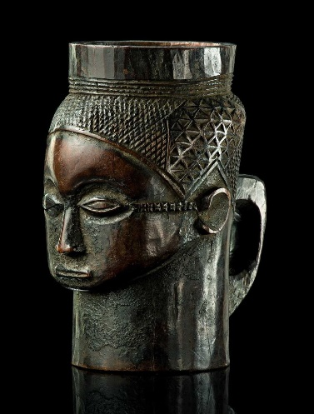
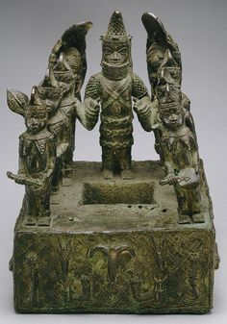
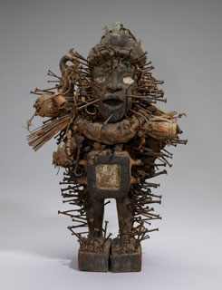

Select one of these and one from the other side
Africa - Number 1
Africa - Number 2
Africa - Number 3

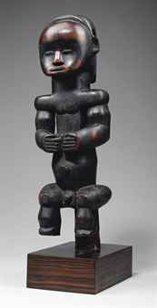
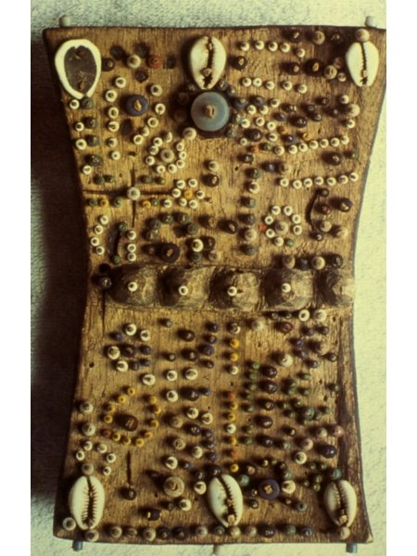
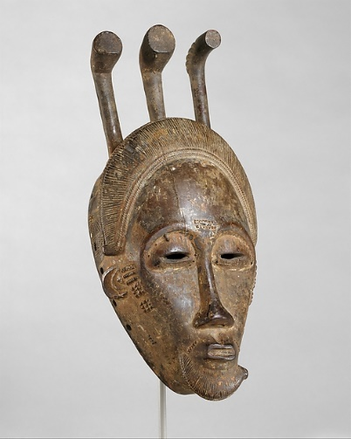

Africa - Number 6
Africa - Number 5
Africa - Number 4
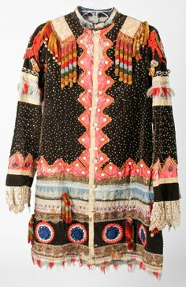
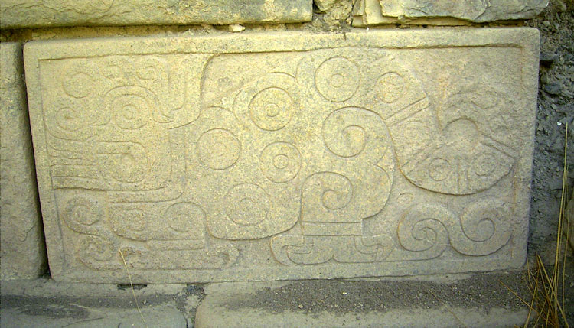

Indigenous - Number 1

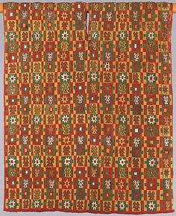
Select one of these and one from the other side
Indigenous - Number 2

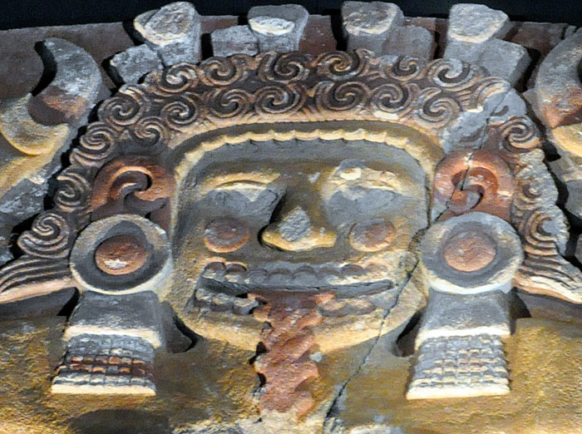

Indigenous - Number 4
Indigenous - Number 3

