The Canon of Polykleitos
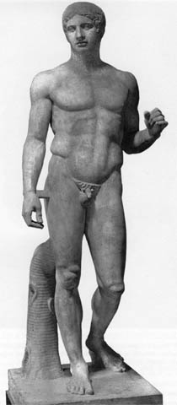

Polykleitos:
Polykleitos was a Greek sculptor from the school of Argos, known for his masterly bronze sculptures of young athletes; he was also one of the most significant aestheticians in the history of art. ("Polykleitos")
Greeks used a system of measures when they made temples and also attempted to use a standard unit of measure to draw the human body. Polykleitos of Argos was the sculpture who best represented the idea of constructing the ideal human figure. (Stockstad 110) Polykleitos influenced artists by making nude figures more popular, along with poised rhythmic poses, and male and female head with characteristic rounded structure and full, oval face. (Becatti 196)

The Canon:
The Canon is a theoretical work that discusses ideal mathematical proportions for the parts of the human body and proposes for sculpture of the human figure a dynamic counterbalance—between the relaxed and tensed body parts and between the directions in which the parts move. ("Polykleitos")
Polykleitos created his method around 450 BCE and called it “The Canon” coming from the Greek word kanon meaning measure, rule, or law. To prove his theory, Polykleitos created a heroic bronze statue of Achilles. Sadly, this statue was destroyed but since it was so widely known, many sculptors redid it. The most commonly known replica is called the Spear Bearer (Doryphoros). Diadumenus and Doryphoros are known only through Roman copies. (Stockstad 110) ("Polykleitos")
Because the statue had been destroyed, scholars spent their time studying the replicas that had been made by Romans to try to find the constant measurement seen in the Canon. They believed that the Canon was based on a ratio of units and the length of various body parts. (Stockstad 110)

The Unit of Measurement:
The unit of measurement is unknown but is thought of as the length of a finger or the length from the hairline to the jaw. Polykleitos also set the standards of symmetria, by setting the lengths of various body parts equal to each other.

[Polykleitos:Doryphoros, original bronze, c. 440–c. 435 BC; Roman copy , marble, h. 2 m (Naples, Museo Archeologico Nazionale); photo credit: Scala/Art Resource, NY Grove Art Online]

Marilyn Stockstad in Art: A Brief History wrote, “In the statue he made to illustrate his treatise, he explored not only proportions but also the relationships among weight-bearing and relaxed legs and arms in a perfectly balanced figure. The cross-balancing of supporting and free elements in a figure is sometimes referred to as contrapposto.” In the picture above, Polykleitos sculpted a male athlete, perfectly proportioned and equally balanced. The position of the left foot suggests movement while the straight leg is supporting the weight of the hero. The left arm is bent to support the weight of the missing spear while the hips and head are turned in favor of the left leg. (Stokstad 110)

