[](https://www.google.com/url?sa=i&rct=j&q=&esrc=s&source=images&cd=&cad=rja&uact=8&ved=0CAcQjRxqFQoTCPCp6Mmu2cgCFQXZPgod6pwB-A&url=https%3A%2F%2Fwww.studyblue.com%2Fnotes%2Fnote%2Fn%2Farth-111-study-guide-2012-13-whatley%2Fdeck%2F9713869&bvm=bv.105841590,d.cWw&psig=AFQjCNH3pnUSkJoqCGKFNxJFNIOkPtMyag&ust=1445716145073969)[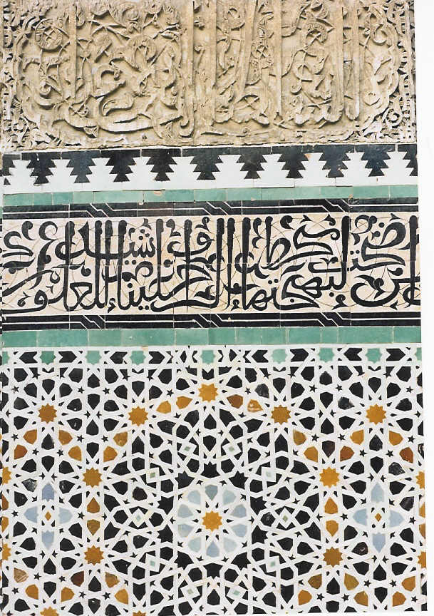](http://www.google.com/url?sa=i&rct=j&q=&esrc=s&source=images&cd=&cad=rja&uact=8&ved=0CAcQjRxqFQoTCOzP3eSu2cgCFYpVPgodd6gPHw&url=http://cook-coquus.com/2013/what-is-couscous-and-how-does-one-prepare-it/&bvm=bv.105841590,d.cWw&psig=AFQjCNH3pnUSkJoqCGKFNxJFNIOkPtMyag&ust=1445716145073969)

[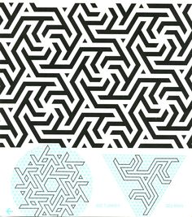](https://www.google.com/url?sa=i&rct=j&q=&esrc=s&source=images&cd=&cad=rja&uact=8&ved=0CAcQjRxqFQoTCPSMpcOv2cgCFQNxPgod8cAG2w&url=https://www.pinterest.com/sacredwheel/happy-kids-math-and-math-art/&bvm=bv.105841590,d.cWw&psig=AFQjCNHLUV1WpKCeCatfzryFI7T0PrDe_A&ust=1445716356226597)

[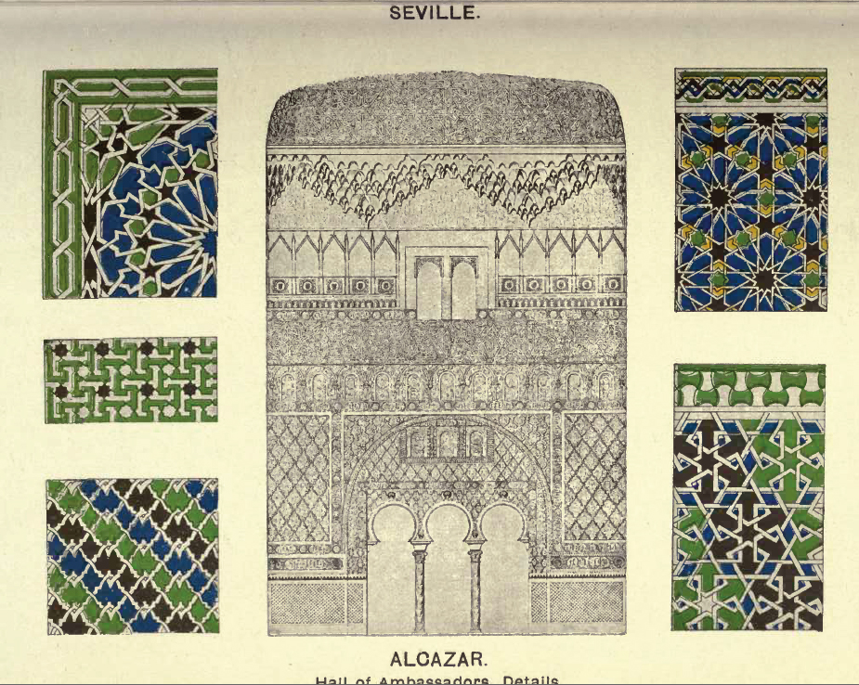](http://www.google.com/url?sa=i&rct=j&q=&esrc=s&source=images&cd=&cad=rja&uact=8&ved=0CAcQjRxqFQoTCNfunv6v2cgCFcJ0PgodaZ0JZw&url=http://surfacefragments.blogspot.com/2010/10/moorish-remains-in-spain.html&bvm=bv.105841590,d.cWw&psig=AFQjCNF7neMQd9ugYR1Iw1PH7Ev7GKjexA&ust=1445716471421921)