1. [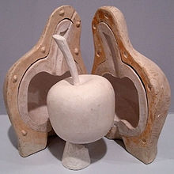](https://en.wikipedia.org/wiki/File:Lost_Wax-Model_of_apple_in_plaster.jpg)[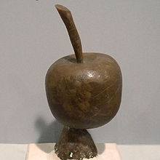](https://en.wikipedia.org/wiki/File:Lost_Wax-Model_of_apple_in_wax.jpg) 2.

3 4

[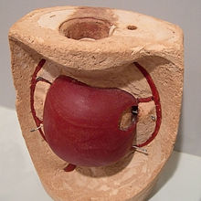](https://en.wikipedia.org/wiki/File:Lost_Wax-Moldmaking_of_an_apple.jpg)

[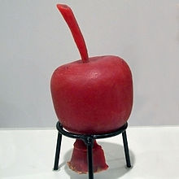](https://en.wikipedia.org/wiki/File:Lost_Wax-Model_of_apple_in_paraffine.jpg)

[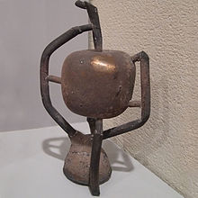](https://en.wikipedia.org/wiki/File:Lost_Wax-Apple_in_bronze.jpg)[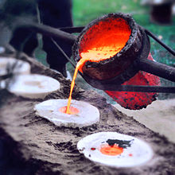](https://en.wikipedia.org/wiki/File:Born_bronze_-_Bronze_casts.jpg)5 6