Chartres Cathedral

First, together, let’s find the parts of Chartres Cathedral. Look at this diagram and be ready to come point out a part of the image:

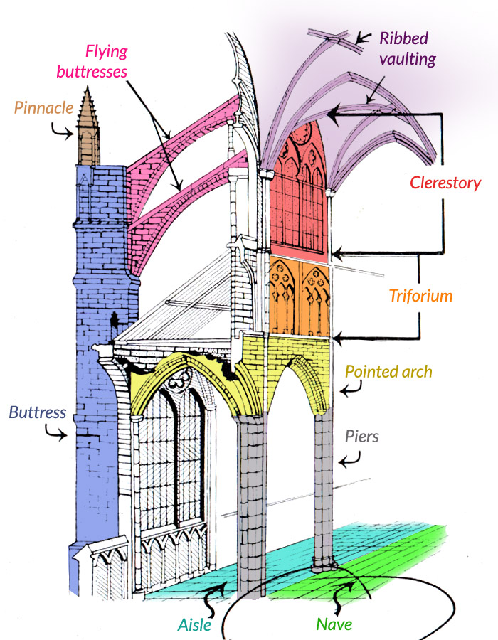

Watch this video and answer the questions below:
http://smarthistory.khanacademy.org/Gothic.html

If it’s working, I might also ask you to do things on this dope website:
http://mappinggothic.org/building/1107

- (from the caption below the video) What are the two dates of construction for Chartres Cathedral?

- (and now, watch the video) What is the relic that the cathedral houses?

- What happened to the Romanesque cathedral that was originally on the site (and the famous relic)? And what is the significance of that event?

- How is the western part (what is sometimes referred to as Chartres I) different from the rest of the building?

- Describe the door jamb statues of the west portal: How do they fit firmly in the pre-gothic (Romanesque) style? What is their purpose?

- What are the 3 parts of the Chartres “elevation”?

- When they show you the floor plan, what is another difference she talks about between the Romanesque and the Gothic?

- What is the function of a “flying buttress”? What changes to the interior architecture did it allow?

- What do you call the big round stained glass windows?

- What do you call the thin, tall windows underneath it?

- What is the subject of the archivolts of the North Portal?

- How are the door jamb statues of the north portal different (and more Gothic) than their counterparts on the West Portal?

