Architecture Scavenger Hunt

Word | Definition | Example
Ambulatory | A passageway around the apse of a church | 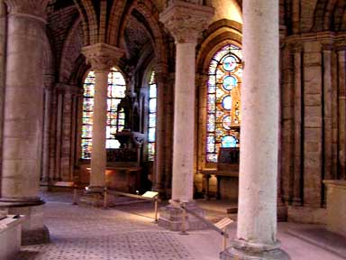
Apse | Traditionally, the apse (where the altar is located) is at the east end of a church | 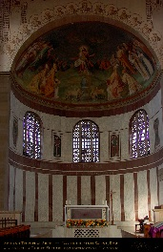
Arcade | A series of arches supported by pillars, piers or columns | 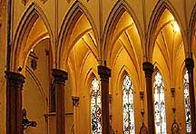
Arch: Round or Gothic | A curved or pointed structural member which is supported at the sides or ends | 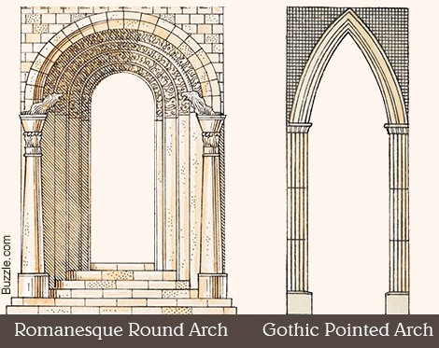
Archivolt | One of several parallel curved, and often decorated, mouldings on the inside of an arched opening | 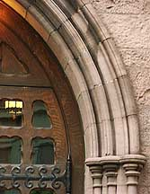
Ashlar Masonry | Smooth square or rectangular stones laid with mortar in horizontal courses | 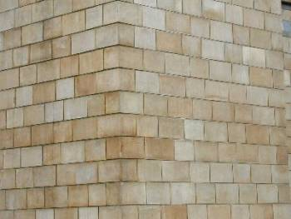
Atrium | A courtyard or patio surrounded by a house (such as an ancient Roman house). May be open to the outside or be roofed with skylights to admit natural light; typically contains plants
Buttress:  Reg. and Flying | A structure, usually brick or stone, built against a wall for support or reinforcement to resist the pressure of an arch or vault | 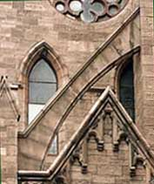  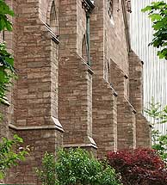
Clerestory | An upper story row of windows; part of an interior wall rising above the adjacent roof with windows admitting light | 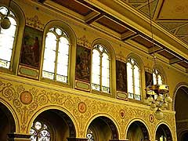
Colonnade | A series of columns in a straight line carrying an entablature. In Classical architecture, a long sequence of columns joined by their entablature, often freestanding | 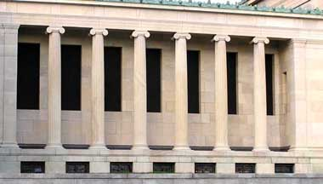
Column | A supporting pillar consisting of a base, a cylindrical shaft, and a capital. Column vs. post: post lacks the essential qualities of a column: base, shaft and capital
Compound Pier | In Romanesque and Gothic architecture, feature of a nave arcade designed for the support of arches and to bring arch and pier into harmony | 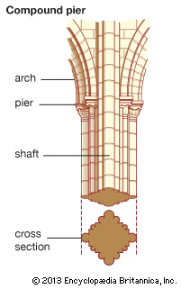
Concrete | Concrete - a Roman invention - was made from a changing recipe of lime mortar, volcanic sand, water, and small stones
Cornice:  Norm & raking | In classical architecture, the third or uppermost division of an entablature, resting on the frieze. (Includes dentil molding where present)  Raking: A cornice following the slope (the angled sides) of a gable, pediment or roof | 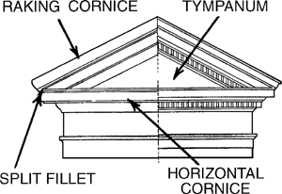
Dome | A dome is a convex roof. | 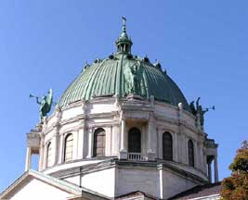
Façade | The exterior face of a building which is the architectural front | 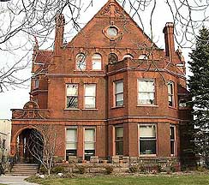
Finial | An ornament, usually foliated, on top of a peak of an arch or arched structure, e.g., a spire, pinnacle or a gable | 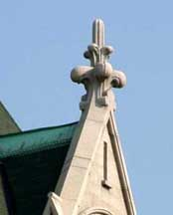
Gable | That part of the wall immediately under the end of a pitched roof, cut into a triangular shape by the sloping sides of the roof | 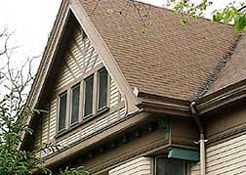
Jambs | One of a pair of vertical posts or pieces that together form the sides of a door, window frame, or fireplace | 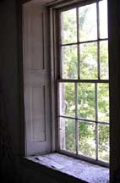
Keystone | The central stone, sometimes carved, in the curve of an arch or vault; the central voussoir of an arch | 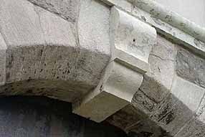
Lancet Window | A narrow window with a sharp pointed arch | 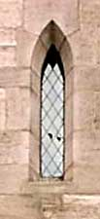
Nave | The central aisle; the part of a church located between the chief entrance and the chancel, and separated from the side aisles by piers or columns  This is the area where the congregation sits in pews. | 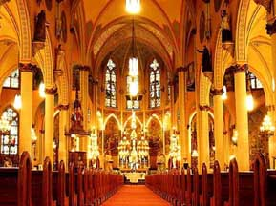
Niche | a curved space in a wall that is designed to hold a statue, vase, etc. | 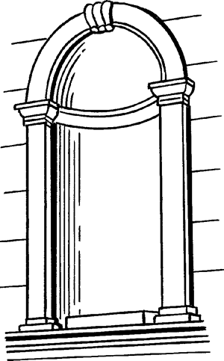
Pediment | A triangular gable across a portico, door or window; any similar triangular decorative piece over a doorway, fireplace, etc. | 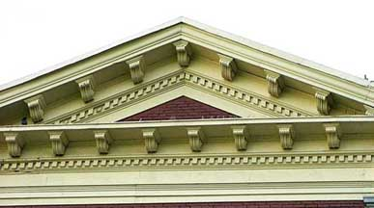
Pilaster | A shallow rectangular column projecting only slightly from a wall and, in classical architecture, conforming with one of the orders. Used to frame doorways, fireplaces, etc. | 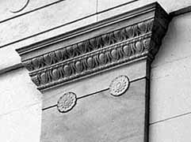
Plinth | 1- A square or rectangular base for column, pilaster, or door framing  2- When used as a solid monumental base, often inscribed with moldings, bas reliefs, or inscriptions, to support a statue or memorial | 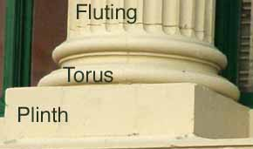
Portico | A roofed entrance porch supported on at least one side by columns | 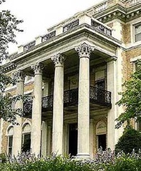
Post  and Lintel | Horizontal beams (lintels) are borne up by columns (posts)  The fundamental principle of Greek architecture. The arcuated system -- that involving the use of arches -- was not used by the Greeks. | 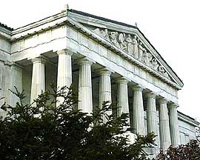
Rose Window | A round window divided into segments by stone mullions and tracery that imitate a multi-petalled rose | 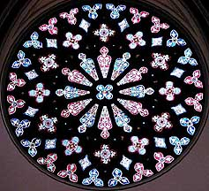
Revetment | the decorative marble paneling that clads the lower walls of a Byzantine church | 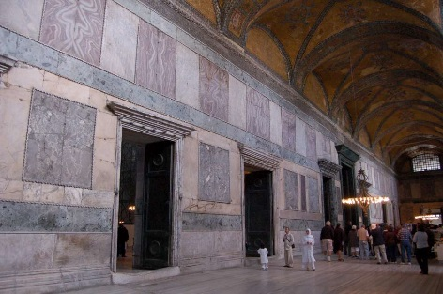
Ridgepole | The horizontal beam at the ridge of a roof, to which rafters are attached. | 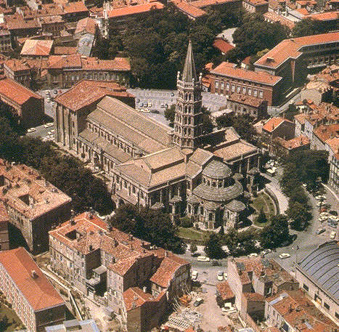
Rusticated  Stone | Masonry cut in large blocks separated by deep joints and sometimes a roughened surface, used to give a bold, exaggerated look to the lower part of an exterior wall, or to frame a door or window | 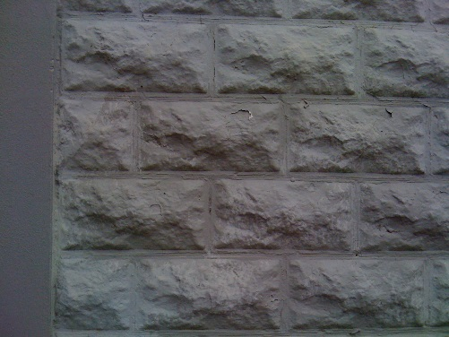
Spandrel | 1. The approximately triangular shape between the curve of an arch and the rectangular frame above it  2. The approximately triangular shape between two arches and the horizontal line that runs above them | 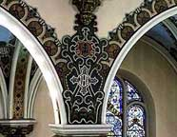  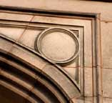
Stringcourse | A molding or projecting course running horizontally along the face of a building | 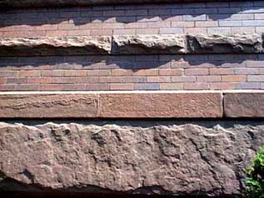
Trumeau | Trumeau, in architecture, is the central pillar or mullion supporting the tympanum of a large doorway, commonly found in medieval buildings.[1] It is often sculpted. | 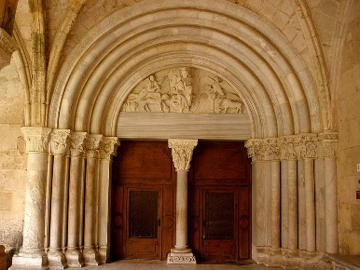
Tympanum | The triangular recessed face of a pediment; the space enclosed by a lintel and an arch over a doorway | 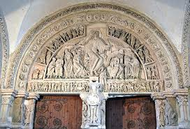
Vault | An arched structure of stone, brick, or reinforced concrete, forming a supporting structure of a ceiling or roof | 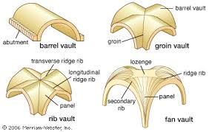
Voussoir | One of the wedge-shaped blocks forming the curved parts of an arch or vault  The central voussoir, which sets the arch, is the keystone | 