Foreshortening
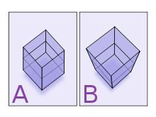
Two different projections of a stack of two cubes, illustrating oblique parallel projection foreshortening ("A") and perspective foreshortening ("B")

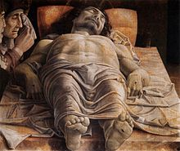
Andrea Mantegna, The Lamentation over the Dead Christ

Epimetheus (lower left) and Janus (right). The two moons appear close because of foreshortening; in reality, Janus is about 40,000 km farther from the observer than Epimetheus.

Foreshortening is the visual effect or optical illusion that causes an object or distance to appear shorter than it actually is because it is angled toward the viewer. Additionally, an object is often not scaled evenly: a circle often appears as an ellipse and a square can appear as a trapezoid.
In painting, foreshortening in the depiction of the human figure was perfected in the Italian Renaissance, and the The Lamentation over the Dead Christ by Andrea Mantegna (1480s) is one of the most famous of a number of works that show off the new technique, which thereafter became a standard part of the training of artists.

