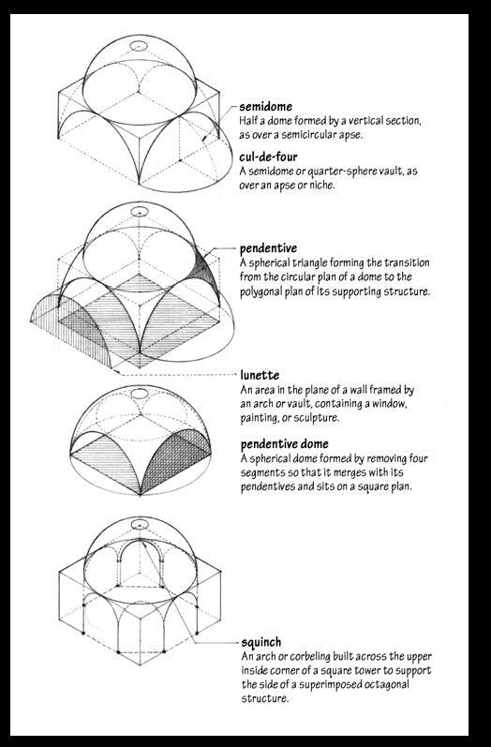
A pendentive is a constructive device permitting the placing of a circular dome over a square room or an elliptical dome over a rectangular room.

The squinches are the architectural support that transition weight from the dome down to the piers.

In the mosque of Selim II they allow the round base of the dome to join octagon formed by the piers. A complex system of exterior buttresses support the east and west piers and do most of the work to hold up the massive weight of the dome. These buttresses are artfully hidden among the exterior porticos and galleries.

