Category 2 _____________________________________

What are the common Characteristics?

Cathedral of St. Mary of the Assumption, Pisa, Italy
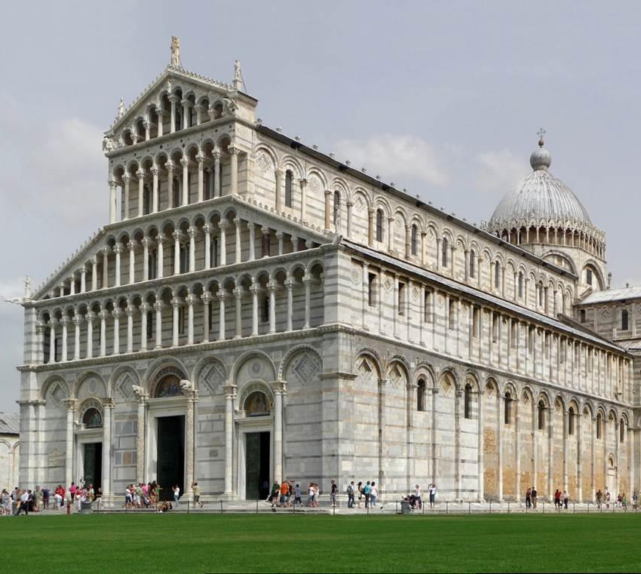

Cathédrale Saint-Pierre d'Angoulême

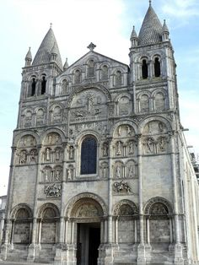

Basilica, Paray-le-Monial, France, 1090-1110.
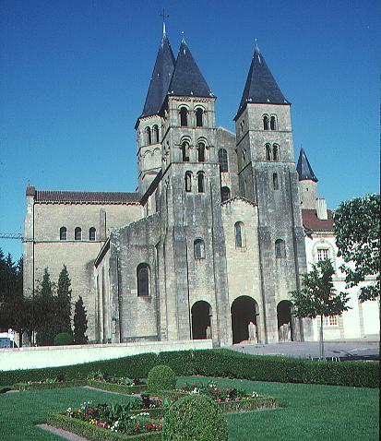

Abbey Church, Fontenay, 1139-47
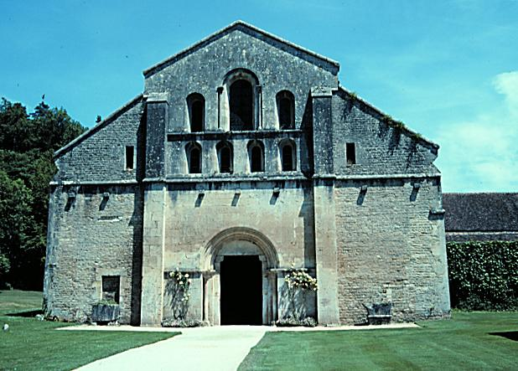

Milan Cathedral

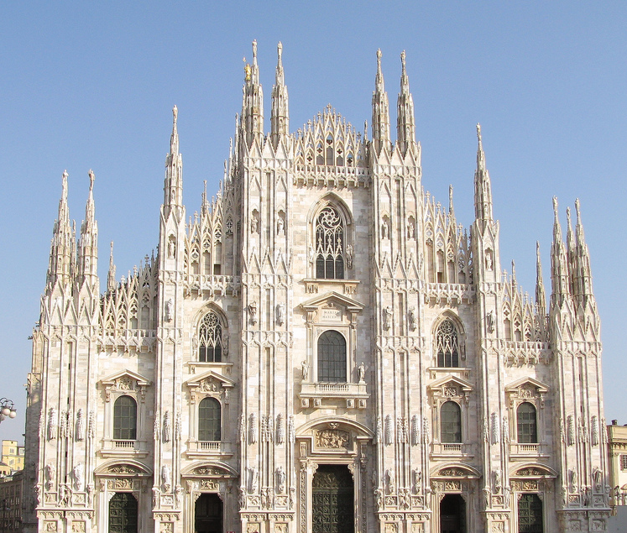

Saint Finbars

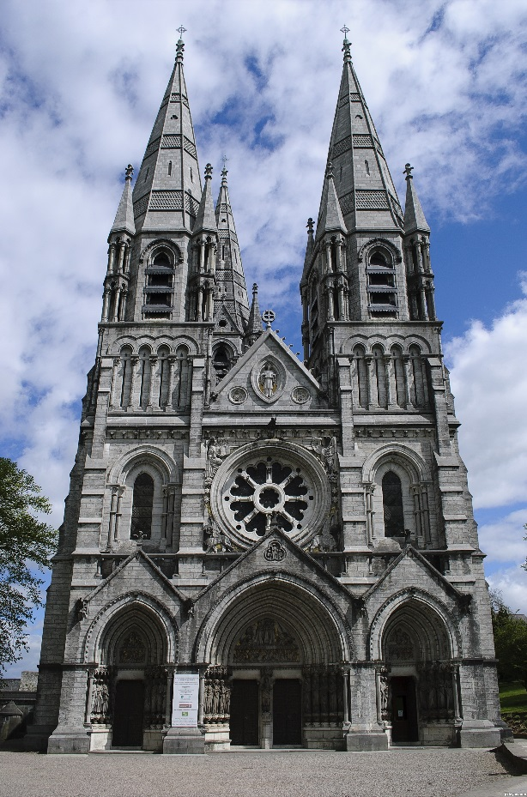

Reims Cathedral

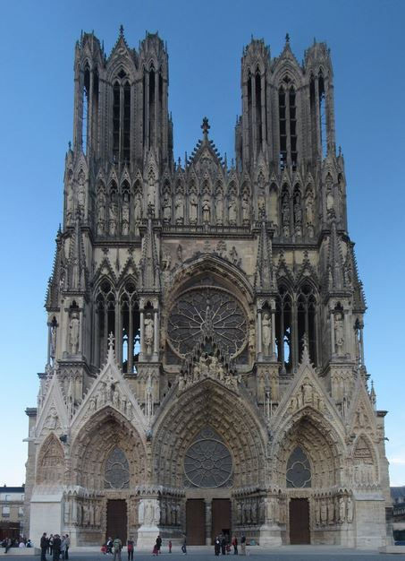

Notre Dame

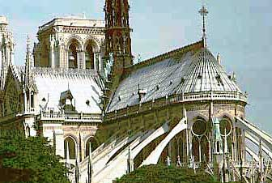

San Vitale – outlier

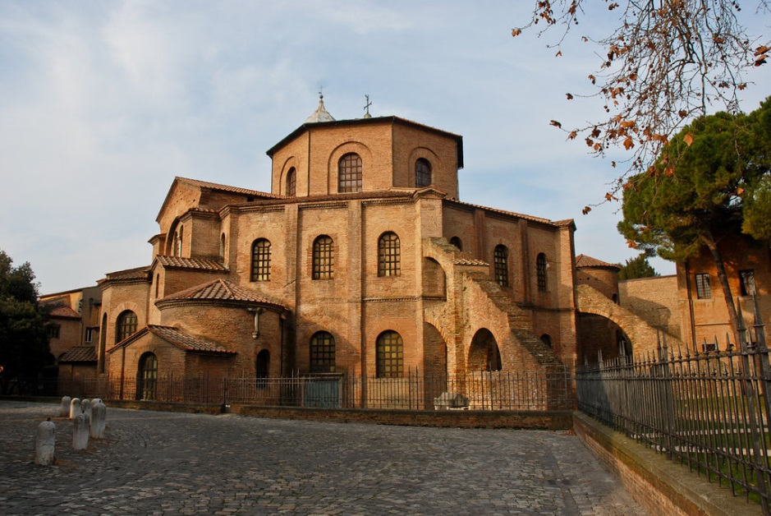

Santa Sabina – outlier

