Art History
Global Prehistory
Test

- These images show an overview and detail of the Parthenon. (15 minutes)

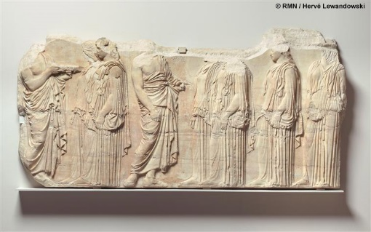
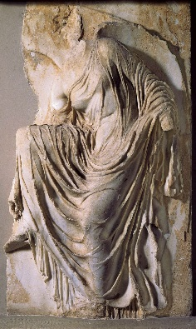
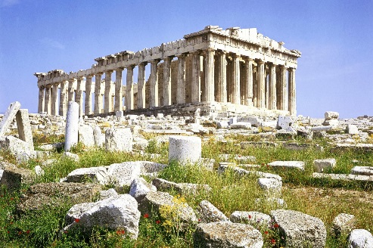

During what time period was the site constructed and for what purpose?

Why was the selection of this site significant?

Using specific visual and contextual evidence, explain how the sculptural program of the Parthenon addresses both the religious function of the building and its political significance.

- The work shown is a copy of Polykleitos’ Doryphoros. (15 minutes to read; 15 minutes to write)
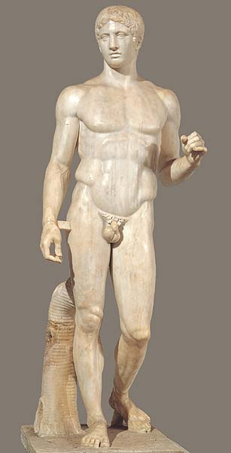

Summarize and/or describe Polykleitos’ ideas about sculpting the human form.

Use both specific visual evidence and Polykleitos’ ideas from his treatise to explain how those ideas shaped the creation of the original Doryphoros.

Analyze why Polykleitos’ ideas, as expressed in the Doryphoros, were so influential in ancient Greece.

- Cultures often have burial traditions that are represented in works of art. This work is Tutankhamun’s Tomb and innermost coffin from the New Kingdom of Ancient Egypt. It is datd from 1323 BCE and is made of gold with inlays of enamel and semi-precious stones. (30 minutes)
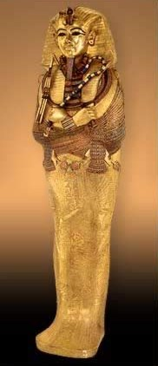

Show how this work represents a bural tradition associated with ancient Egypt.

Discuss specific elements of the work that reflect this burial tradition.

Select and completely identify another work of art that represents a burial tradition.

Show how the second work represents a burial tradition associate with its culture.

Discuss Specific elements of the work that reflect this burial tradition.

You may either select a work from the list below or select one of your own choosing. You are not limited to works in the official image set.

Etruscan, Sarcophagus of the Spouses
Stele of Hegeso

