[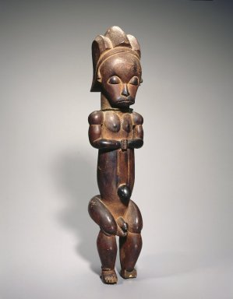](https://www.google.com/url?sa=i&rct=j&q=&esrc=s&source=images&cd=&cad=rja&uact=8&ved=0ahUKEwjCw-j65c_MAhULbj4KHaz-CbAQjRwIBw&url=https://www.brooklynmuseum.org/opencollection/objects/4755/Reliquary_Guardian_Figure_Eyema-o-Byeri&psig=AFQjCNFzmvEg5mLAh8Pb0FNmLPQ1C7j4rw&ust=1462979626303621)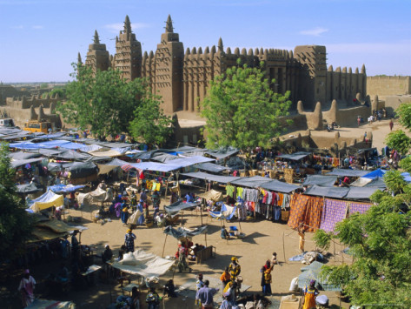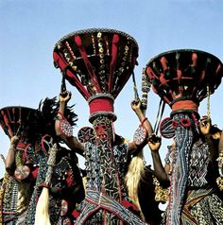

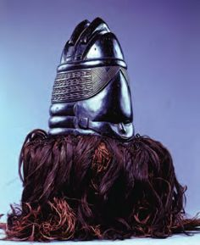

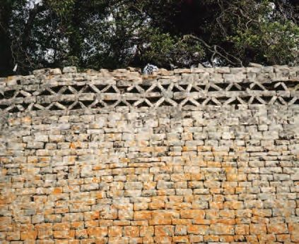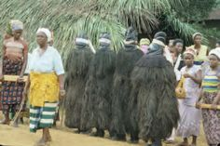

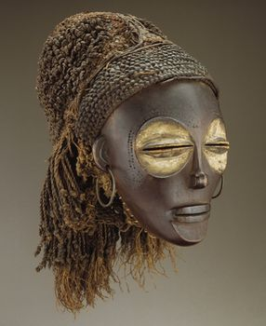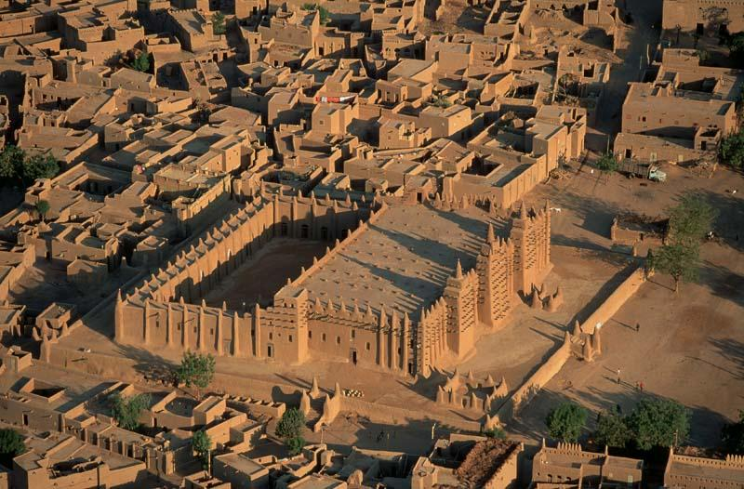

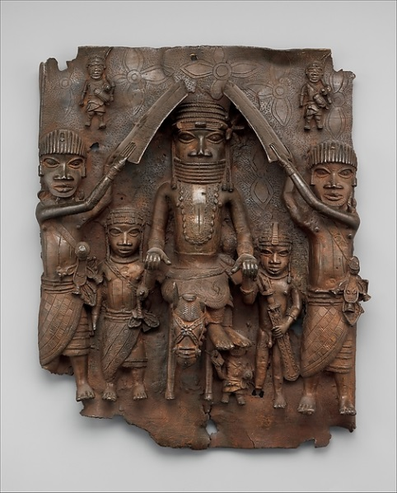

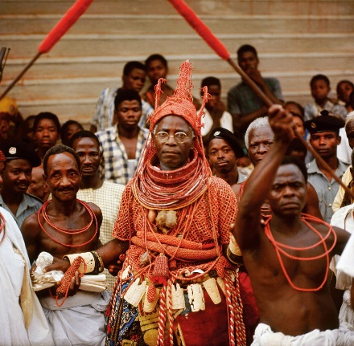

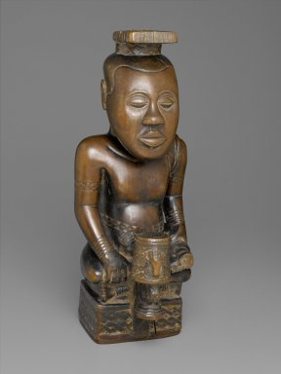

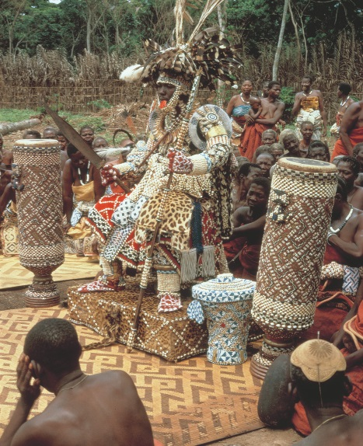

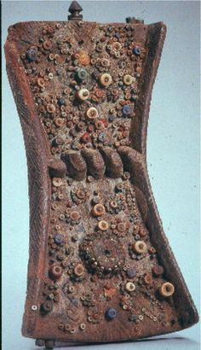[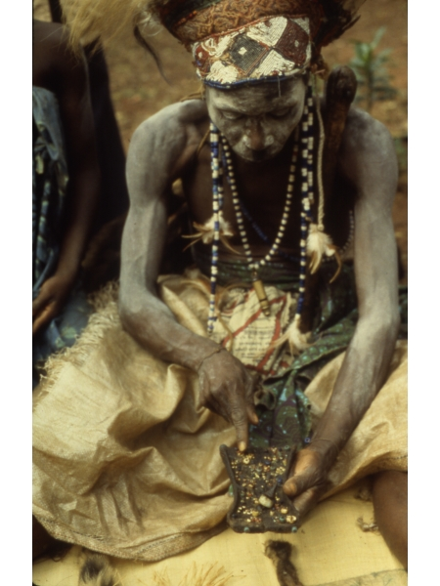](http://www.google.com/url?sa=i&rct=j&q=&esrc=s&source=images&cd=&cad=rja&uact=8&ved=0ahUKEwi1pv2158_MAhUBeD4KHfXaD7AQjRwIBw&url=http://bestaparthistory.weebly.com/africa-22.html&bvm=bv.121421273,d.eWE&psig=AFQjCNGERl48VleF7nwyOK6LGyOja1hnpQ&ust=1462980013810083)

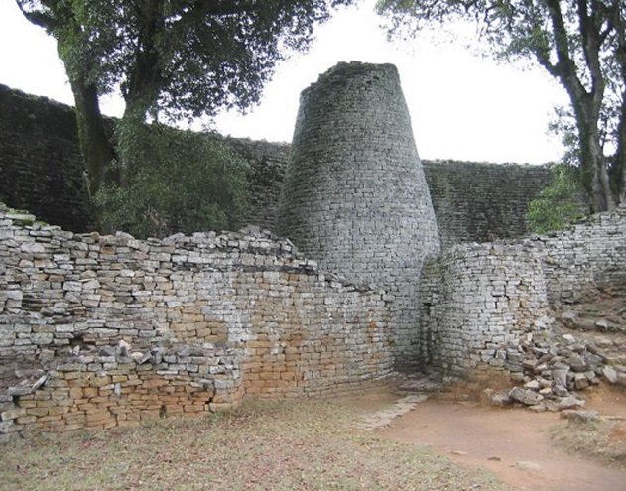

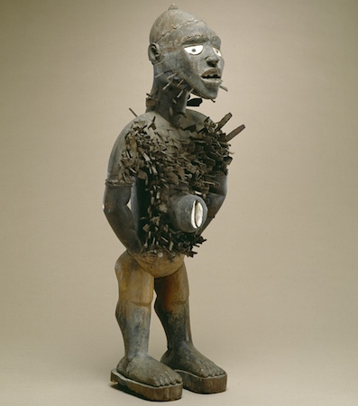

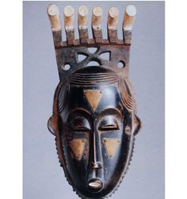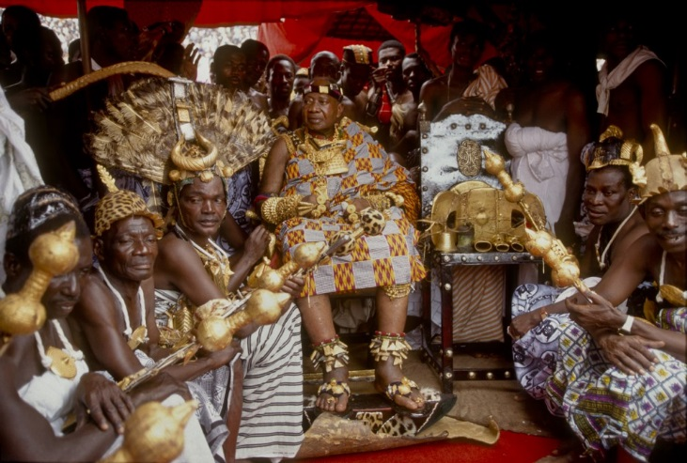

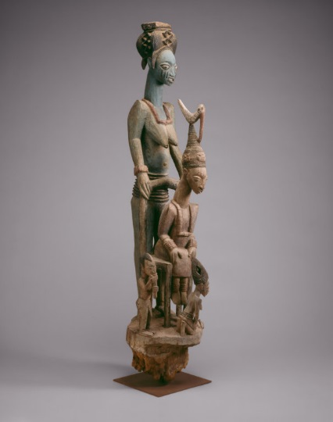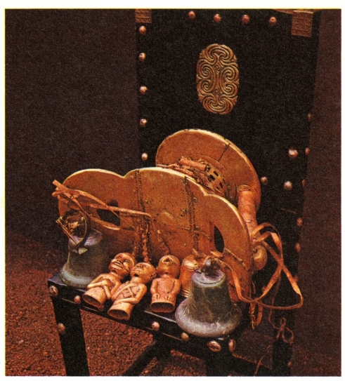

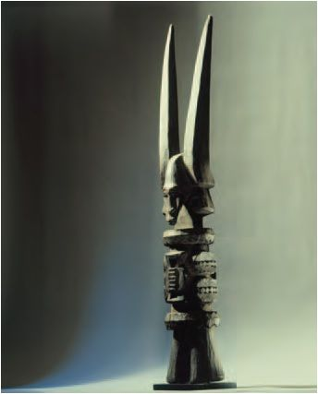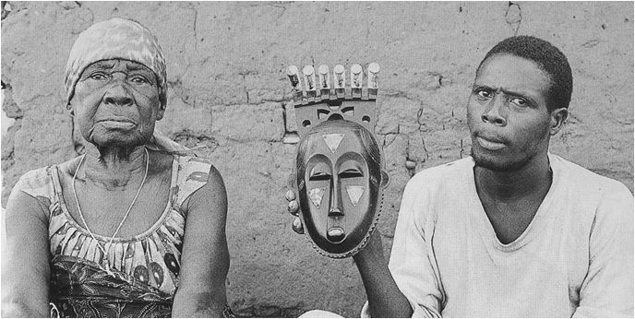

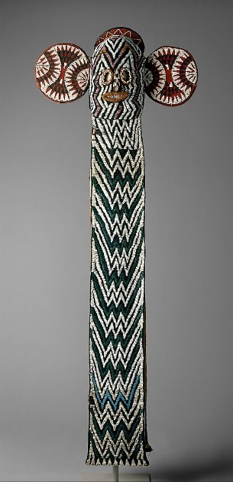

Africa