[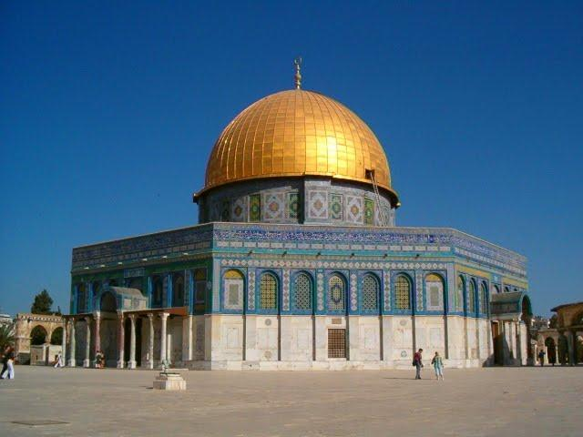](https://www.google.com/url?sa=i&rct=j&q=&esrc=s&source=images&cd=&cad=rja&uact=8&ved=0ahUKEwiks8aX4M_MAhVIcT4KHWhFC68QjRwIBw&url=https://www.studyblue.com/notes/note/n/the-islamic-world/deck/13038172&bvm=bv.121421273,d.cWw&psig=AFQjCNEB5dnrDm69pf6ikl_4IuzmkjW4vQ&ust=1462978071941994)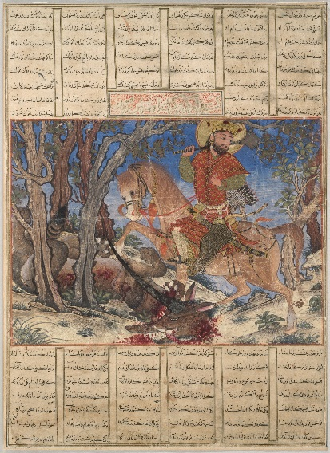

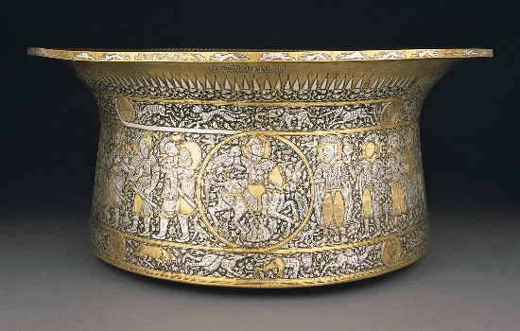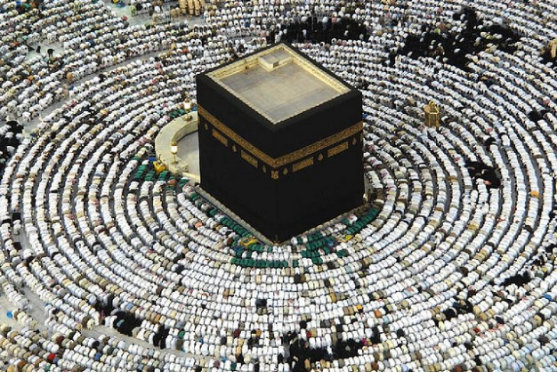

[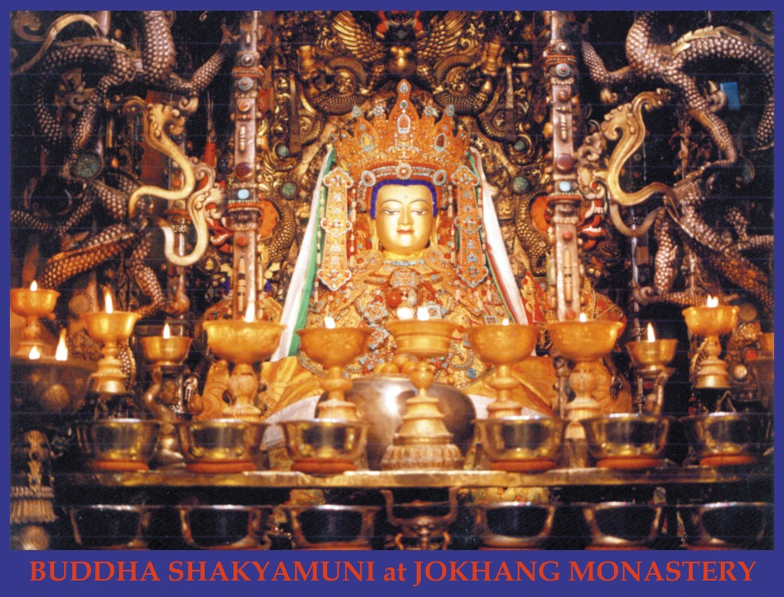](http://www.google.com/url?sa=i&rct=j&q=&esrc=s&source=images&cd=&cad=rja&uact=8&ved=0ahUKEwi0yO7JuonNAhXH8z4KHRhxCqsQjRwIBw&url=http://www.dharma-media.org/ratnashripj/dwnld/thanka/drigung06.html&bvm=bv.123325700,d.cWw&psig=AFQjCNHtNlbwgs-9k-78cBh8rOEwQQZY8A&ust=1464960843983709)



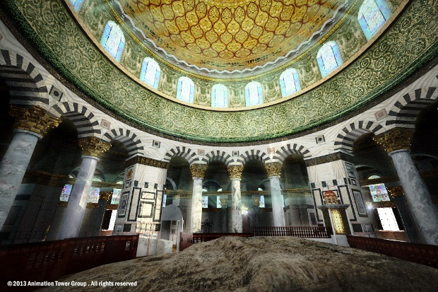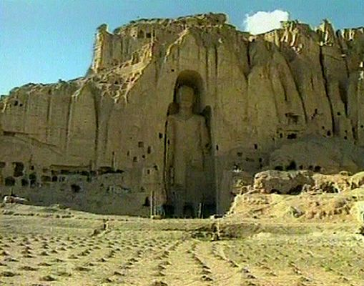

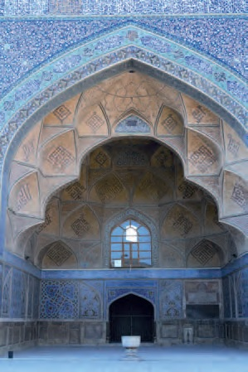

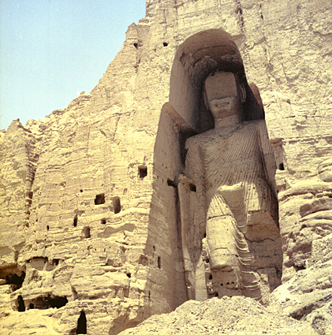

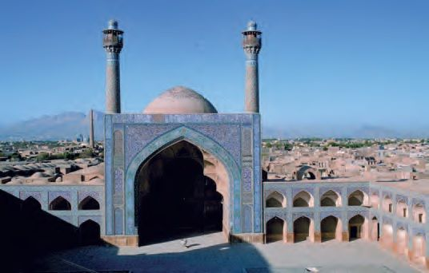

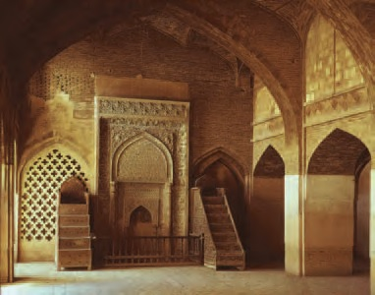

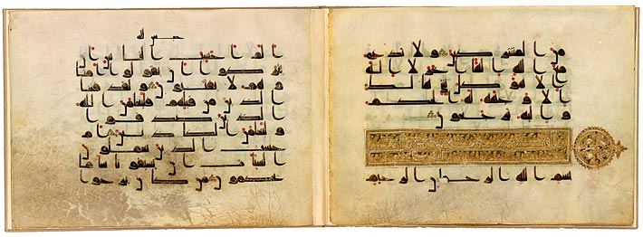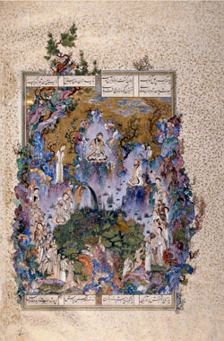

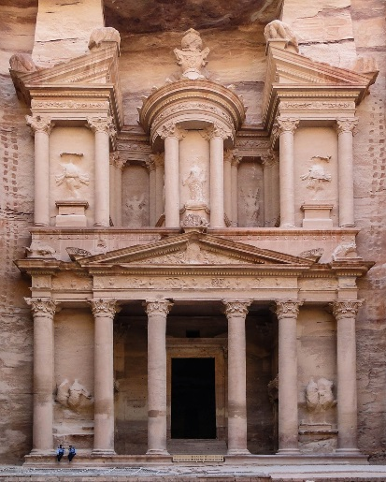

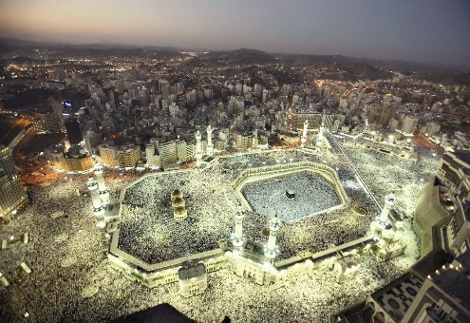

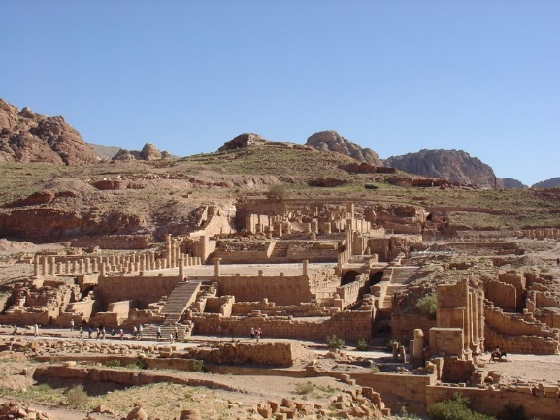

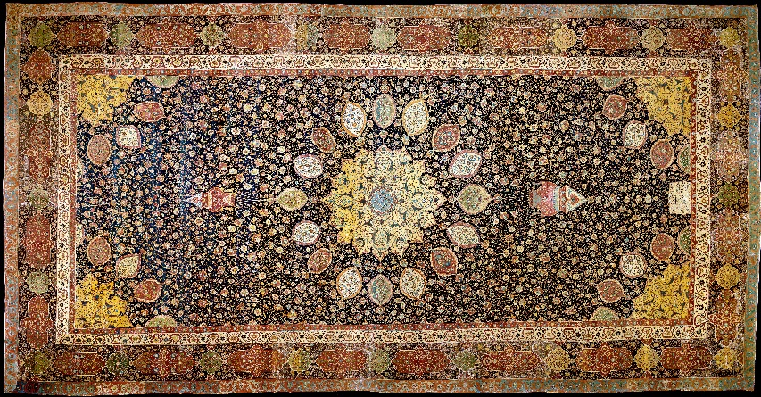

[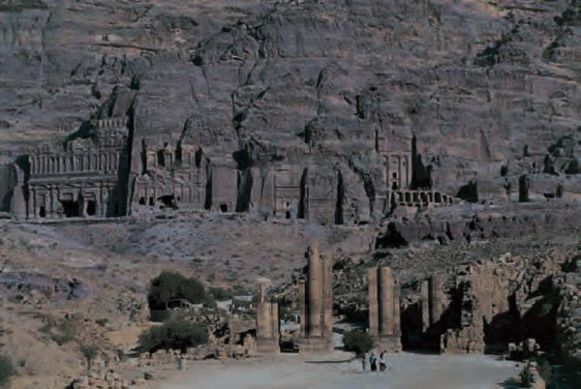](https://www.google.com/url?sa=i&rct=j&q=&esrc=s&source=images&cd=&cad=rja&uact=8&ved=&url=https://www.pinterest.com/pin/166422148705247557/&bvm=bv.121421273,d.cWw&psig=AFQjCNHBLddh3zZCdlR1bFCMOjES2_mjCA&ust=1462977968867295)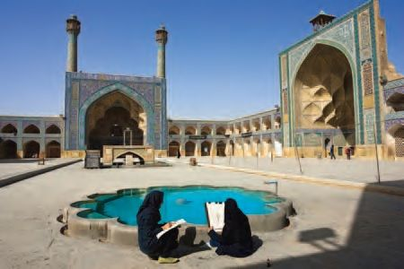

West and central Asia