MP2 Unit Overview: AP Art History
2020-21
Stacey_L_Horman@mcpsmd.org
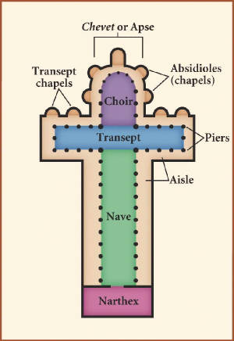
Unit 1: Early Europe and Colonial Americas
Unit 2: Africa
Unit 3: Late Europe and Americas (begin)

Class website for ALL important materials
- www.dhsarthistory.weebly.com
Helpful website for study materials and test prep
- Khan Academy

Art History Quarter 2 Assignments/Points:

- Journals – Sketches, Notes, Responses /20

- AP Style Art Critique (sacred spaces) /20

- Nine-Block Matrix Analysis
  - Early Europe 1 (Christian, Byz, Medieval) /5
  - Early Europe 2 (Islam, Romanesque, Gothic) /5
  - Early Europe 3 (Renaissance) /5
  - Early Europe 4 (Manner, Baroque, Colonial) /5
  - Africa /5

- Writing
  - Unknown Item Attribution /10
  - Indig/Colonial Essay /10
  - Cultural History Essay /15

- MC/Essay Test: Early Europe #1 and #2 /20
- MC/Essay Test: Early Europe #3 and #4 /20
- MC/Essay Test Africa /10

