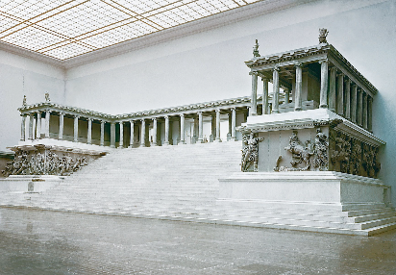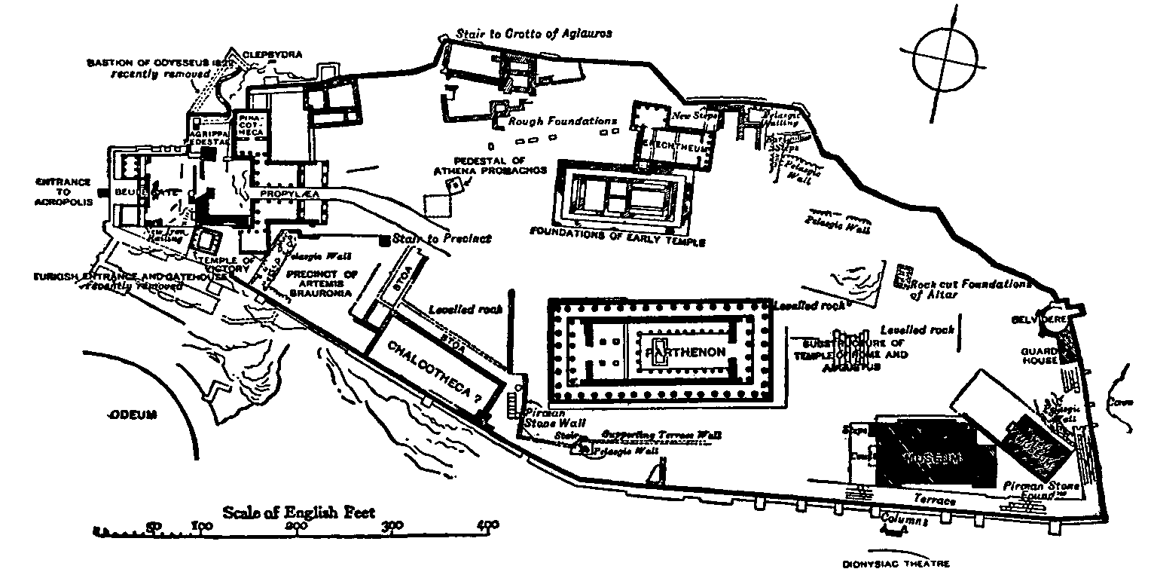

[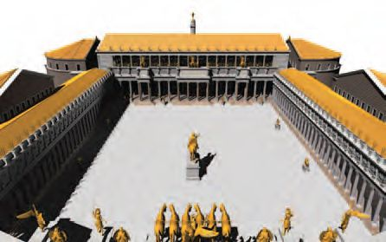](https://www.google.com/url?sa=i&rct=j&q=&esrc=s&source=images&cd=&cad=rja&uact=8&ved=0ahUKEwjl9JGQ18_MAhVKPz4KHVaeCbAQjRwIBw&url=https://www.pinterest.com/pin/166422148705574498/&bvm=bv.121421273,d.cWw&psig=AFQjCNHkSCgUfIyznDNG13DMkmgeDBzkkg&ust=1462975644239749)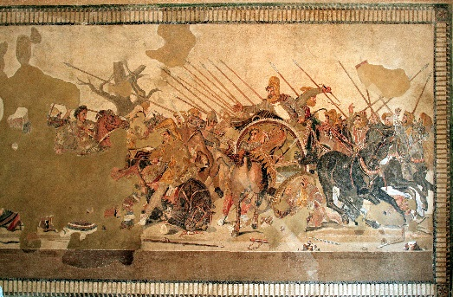

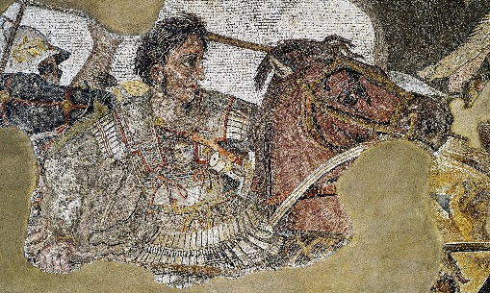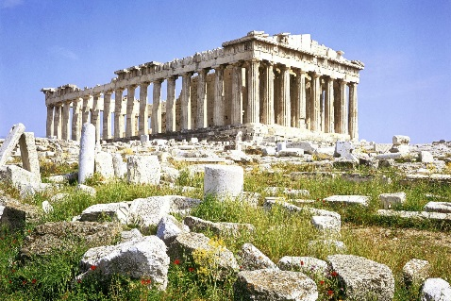

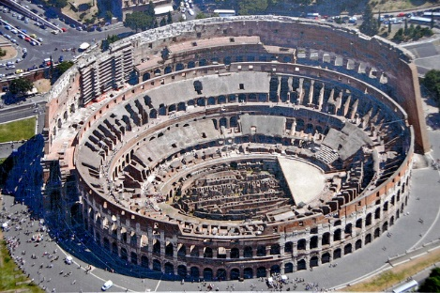

[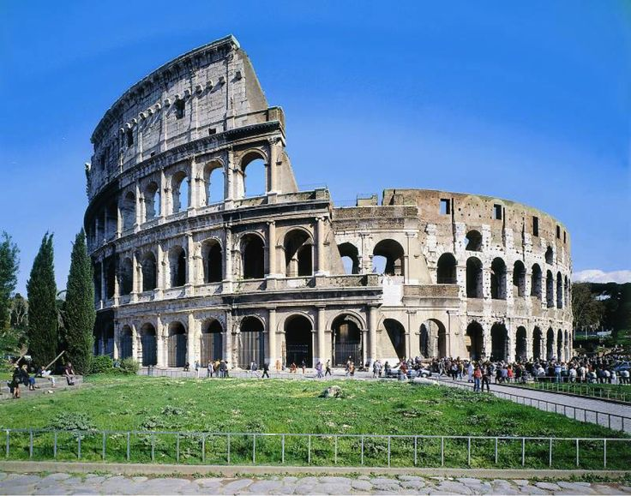](https://www.google.com/url?sa=i&rct=j&q=&esrc=s&source=images&cd=&cad=rja&uact=8&ved=0ahUKEwi0sJei1s_MAhVIOj4KHVmtAK8QjRwIBw&url=https://www.pinterest.com/pin/166422148705574596/&bvm=bv.121421273,d.cWw&psig=AFQjCNHpELCMKPDv9mgvjq2CcXOuZjWJMg&ust=1462975395636825)

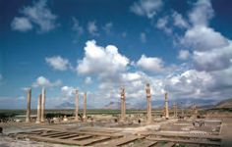

[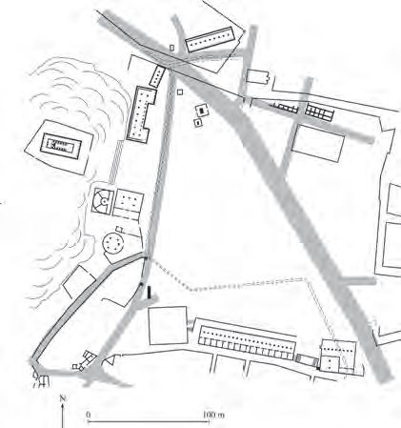](https://www.google.com/url?sa=i&rct=j&q=&esrc=s&source=images&cd=&cad=rja&uact=8&ved=0ahUKEwjEj6nU1M_MAhVCFz4KHTDHDLAQjRwIBw&url=https://www.pinterest.com/pin/166422148705259435/&bvm=bv.121421273,bs.1,d.cWw&psig=AFQjCNE7hncXH-S-LnL_8DhfCIvQ8j41hA&ust=1462974981382502)

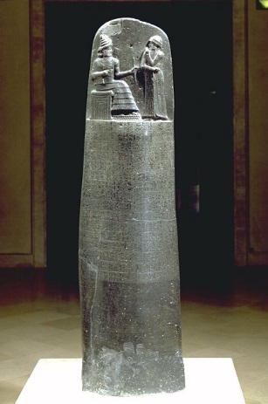

Ancient Med

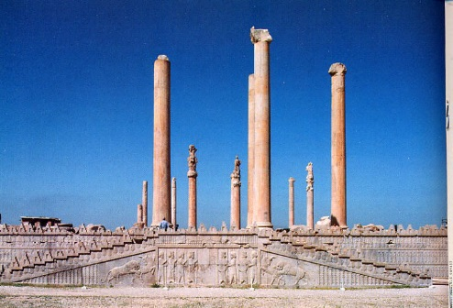

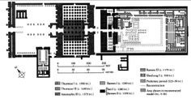

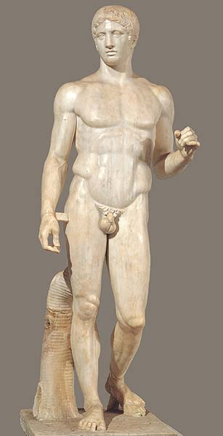

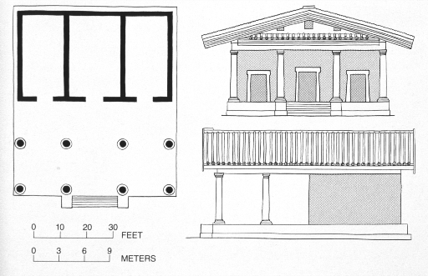

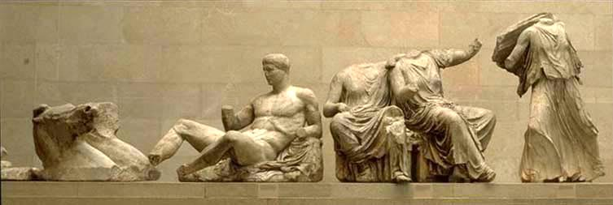

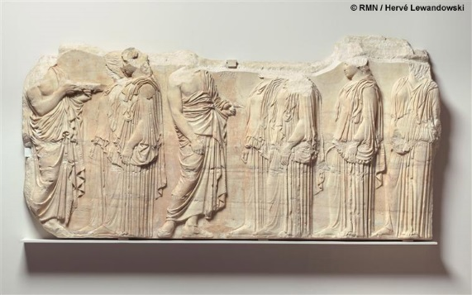

[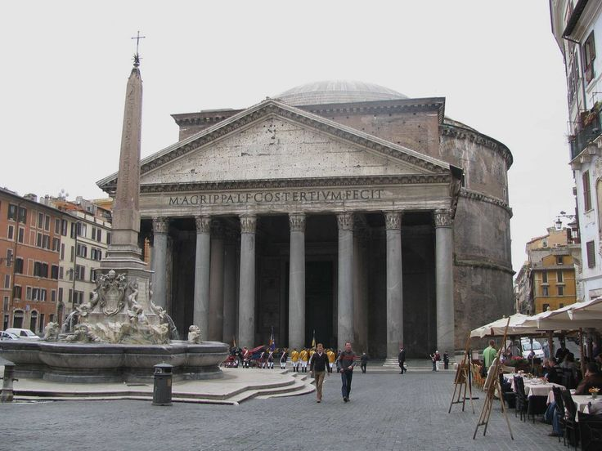](https://www.google.com/url?sa=i&rct=j&q=&esrc=s&source=images&cd=&cad=rja&uact=8&ved=0ahUKEwjkgoHd1s_MAhUHgj4KHcw8BLAQjRwIBw&url=https://www.pinterest.com/jmeschorsch/roman-and-etruscan-art/&bvm=bv.121421273,d.cWw&psig=AFQjCNFqKbO-YnTVdHuSuTx2WzHGTSKTgA&ust=1462975537509909)

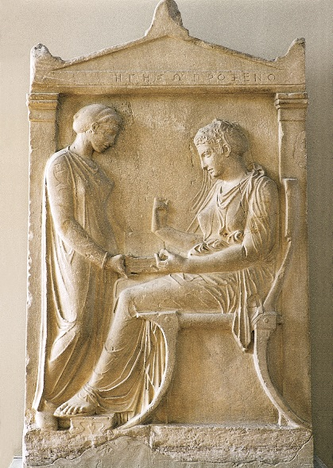

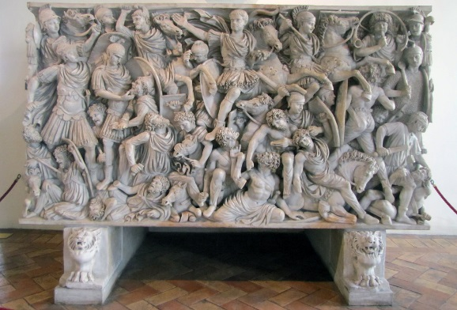

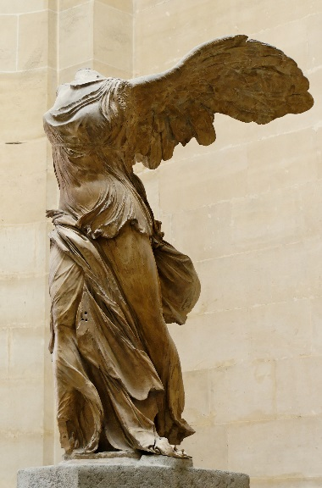

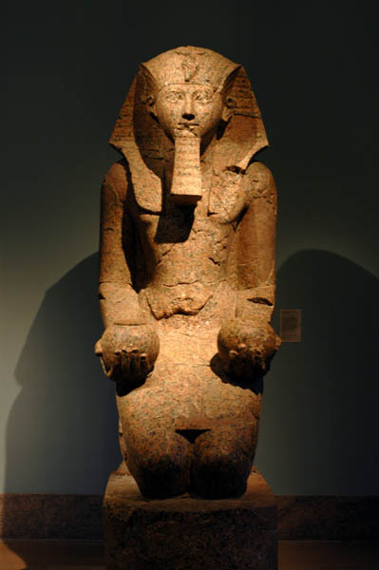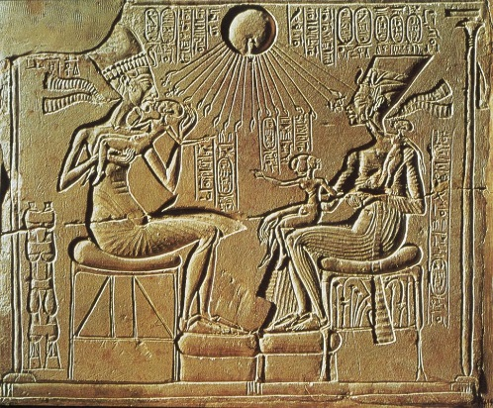

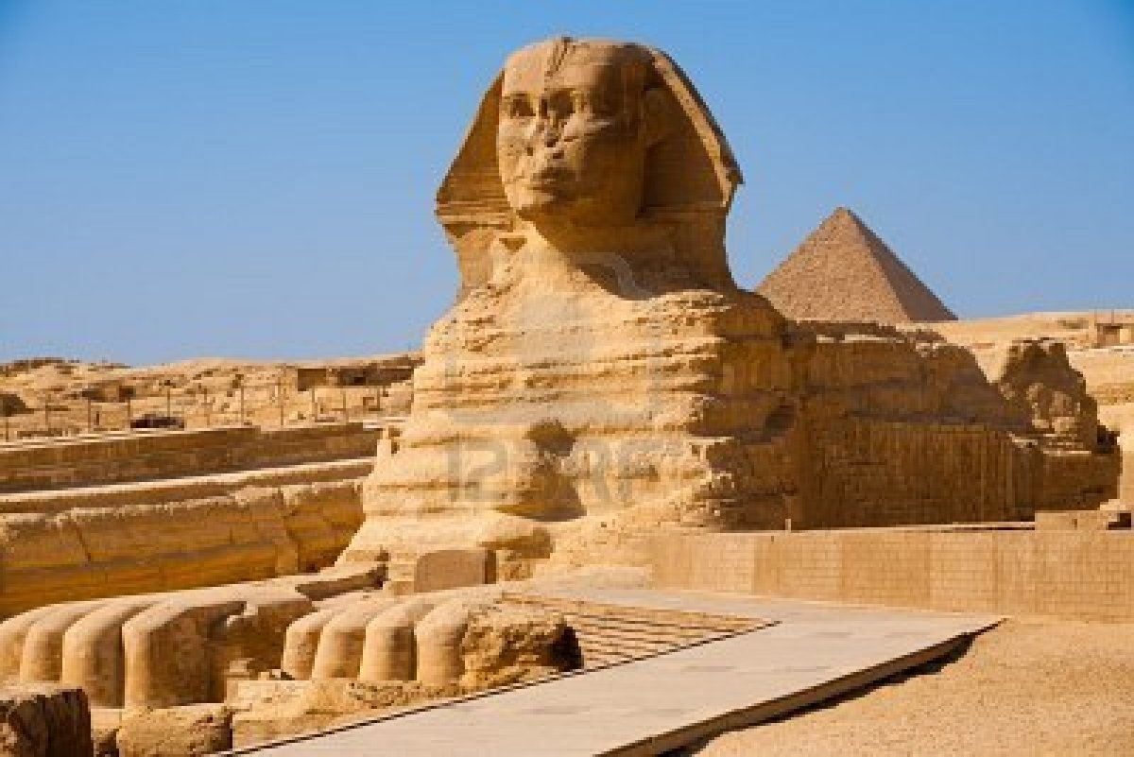

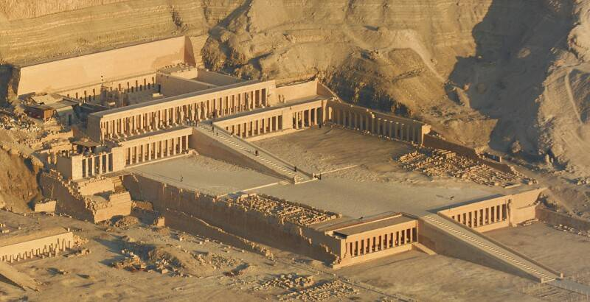

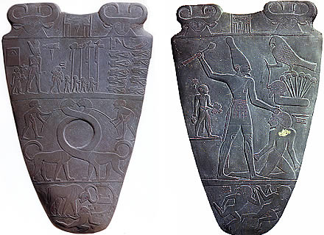

[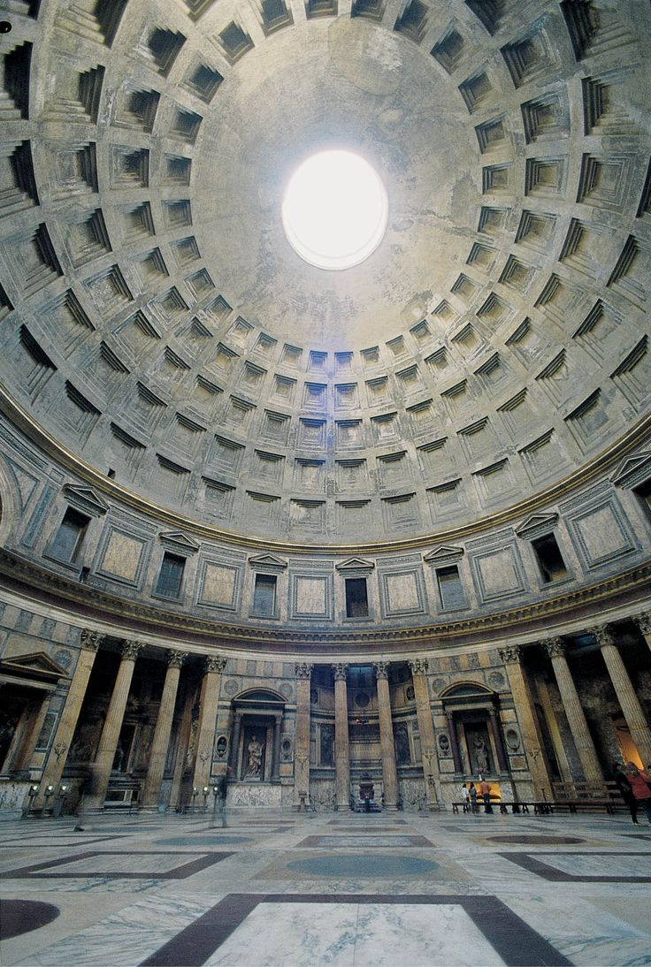](https://www.google.com/url?sa=i&rct=j&q=&esrc=s&source=images&cd=&cad=rja&uact=8&ved=0ahUKEwio_e341s_MAhUDcD4KHYOsAa8QjRwIBw&url=https://www.pinterest.com/pin/166422148705574491/&bvm=bv.121421273,d.cWw&psig=AFQjCNFqKbO-YnTVdHuSuTx2WzHGTSKTgA&ust=1462975537509909)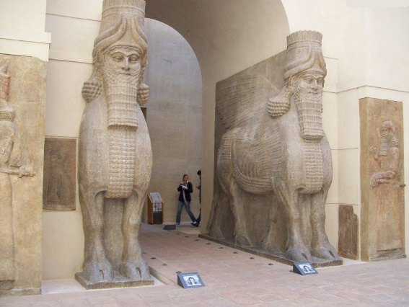

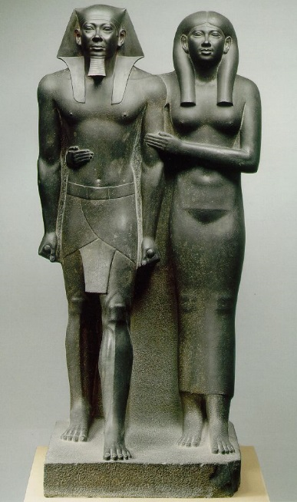

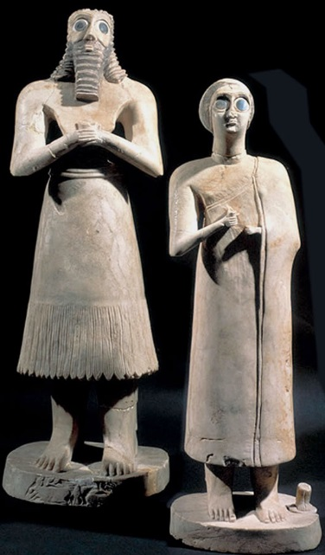

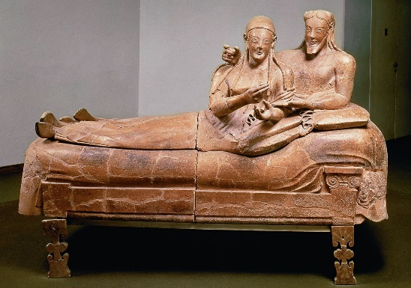

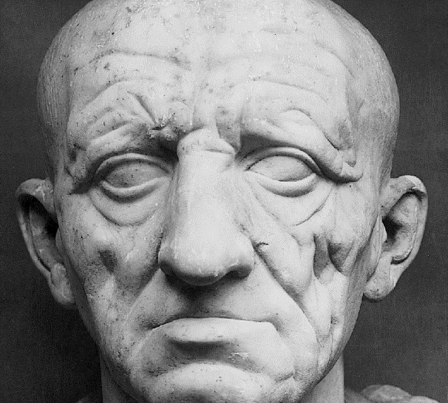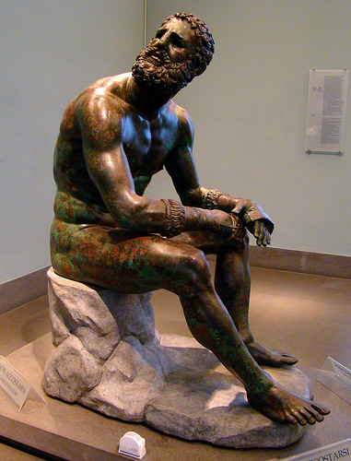

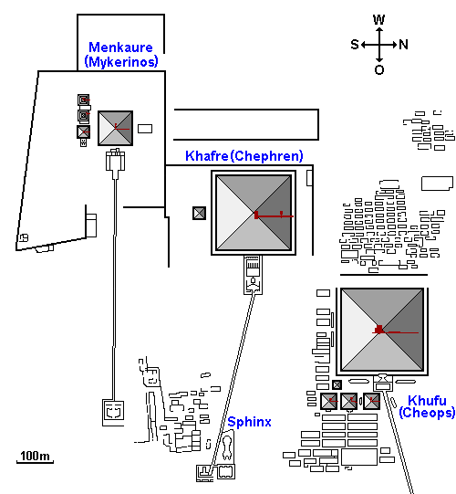

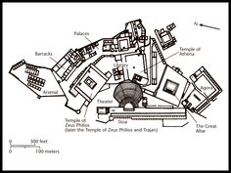

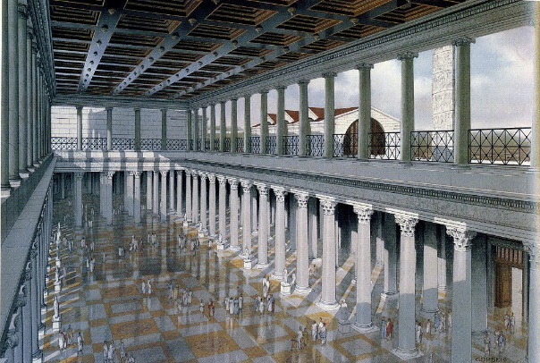

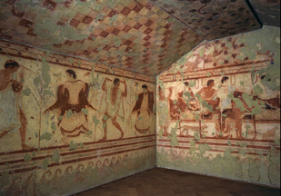

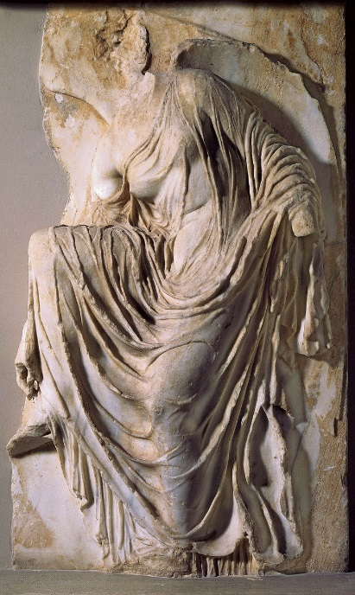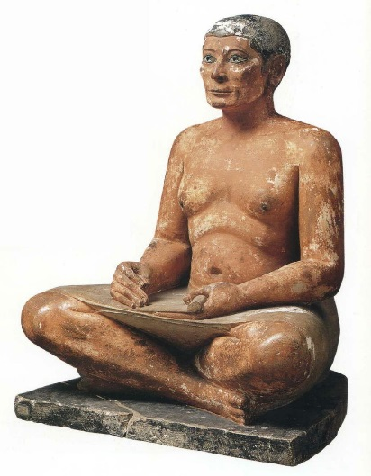

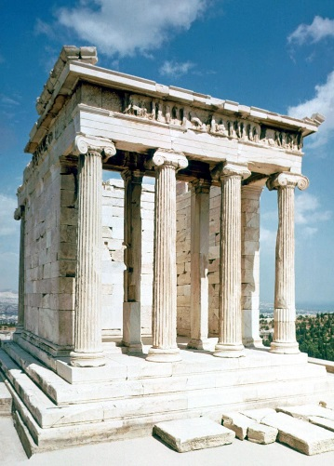

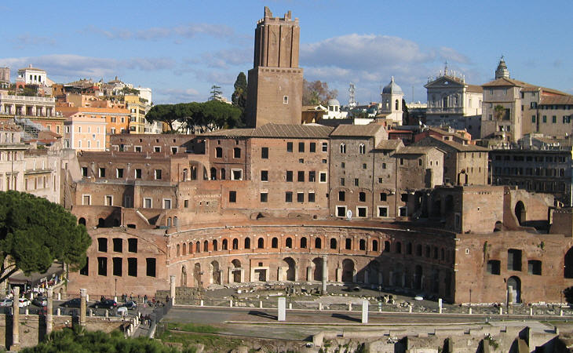

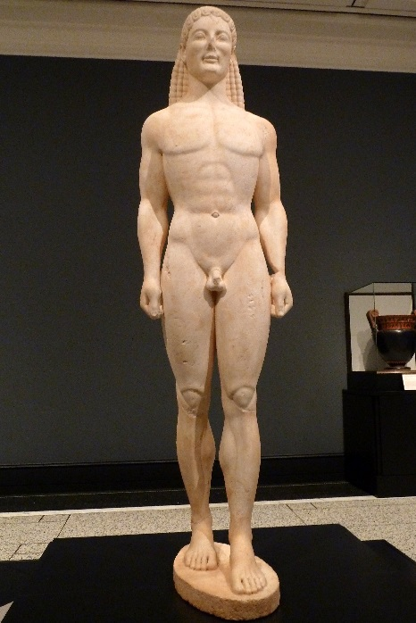

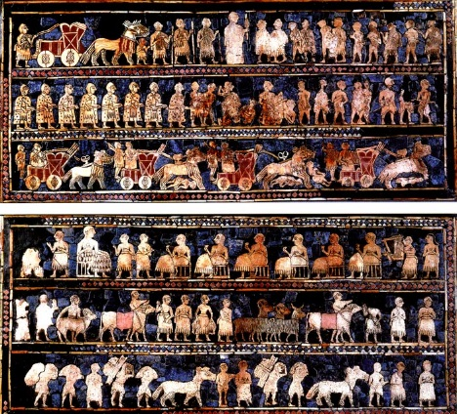

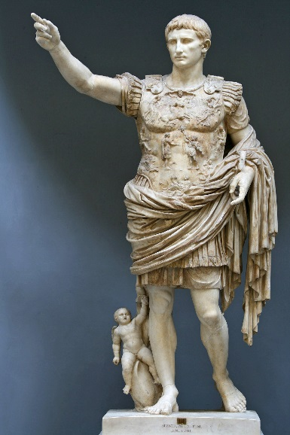

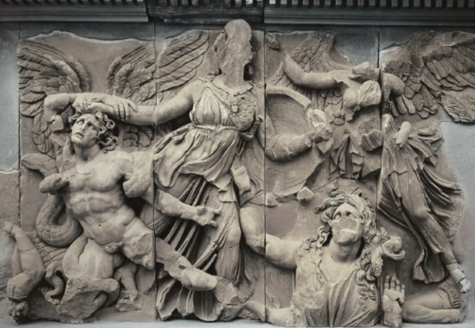

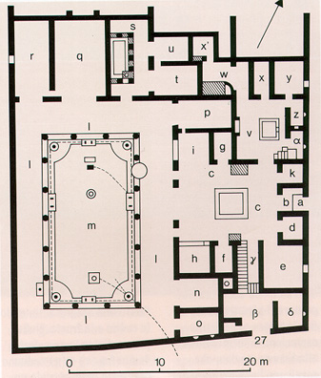

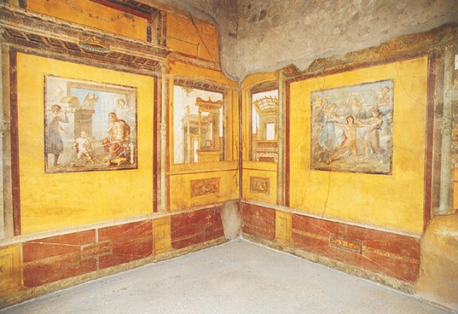

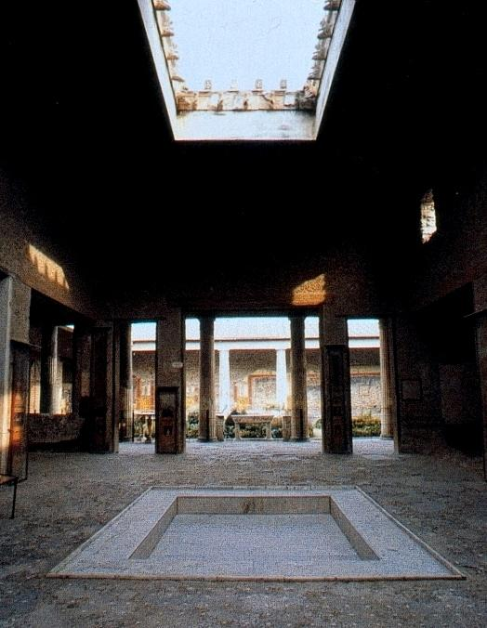

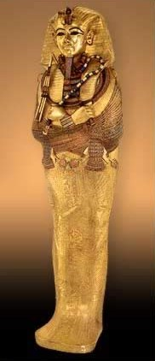

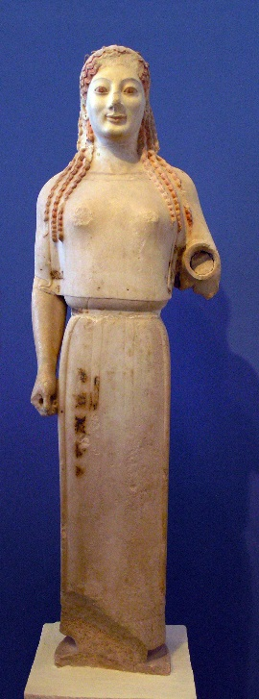

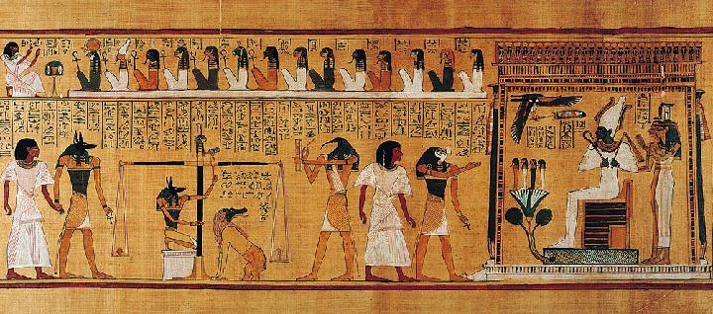

[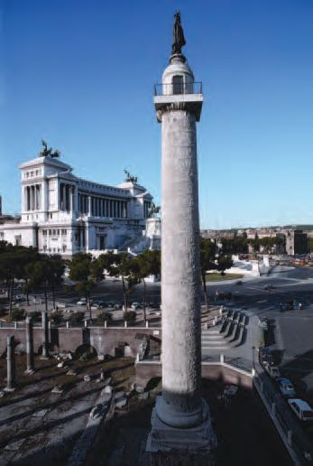](https://www.google.com/url?sa=i&rct=j&q=&esrc=s&source=images&cd=&cad=rja&uact=8&ved=0ahUKEwjYkKav18_MAhXIOz4KHbHjCbEQjRwIBw&url=https://www.pinterest.com/pin/343118065333895904/&bvm=bv.121421273,d.cWw&psig=AFQjCNHkSCgUfIyznDNG13DMkmgeDBzkkg&ust=1462975644239749)

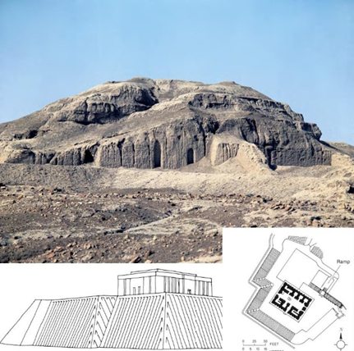

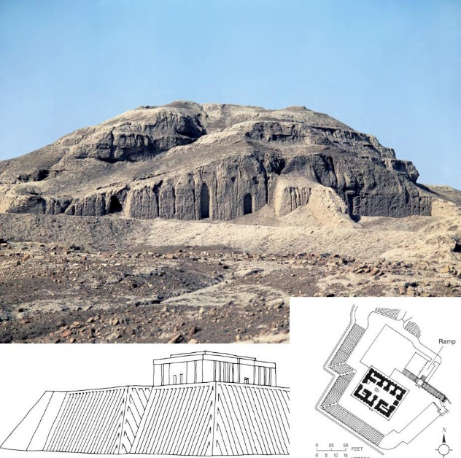

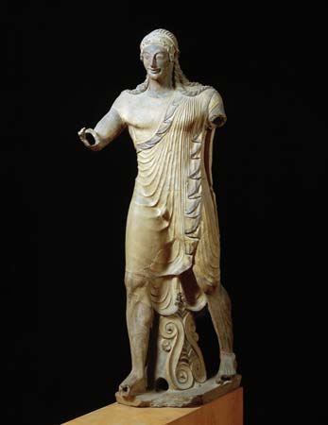

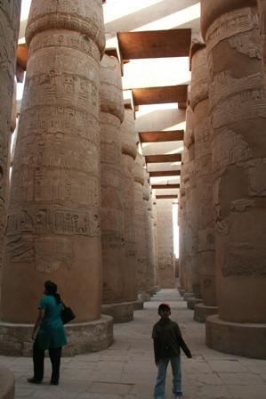

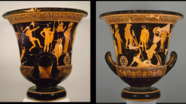

[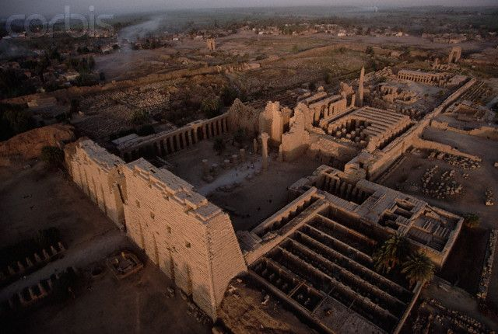](https://www.google.com/url?sa=i&rct=j&q=&esrc=s&source=images&cd=&cad=rja&uact=8&ved=0ahUKEwioqYaj1M_MAhWGbz4KHc0pCVAQjRwIBw&url=https://www.pinterest.com/pin/166422148705258678/&bvm=bv.121421273,d.cWw&psig=AFQjCNHcKA37oeqV92JEnoWUNRPyaPSYKQ&ust=1462974880219617)