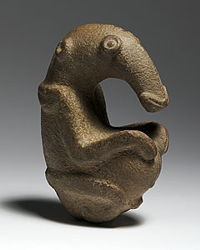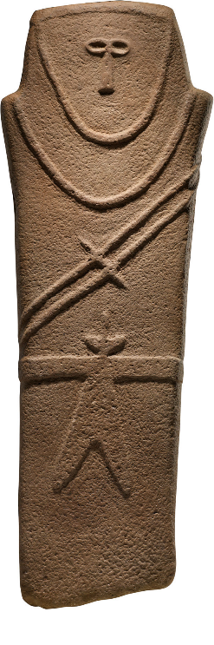

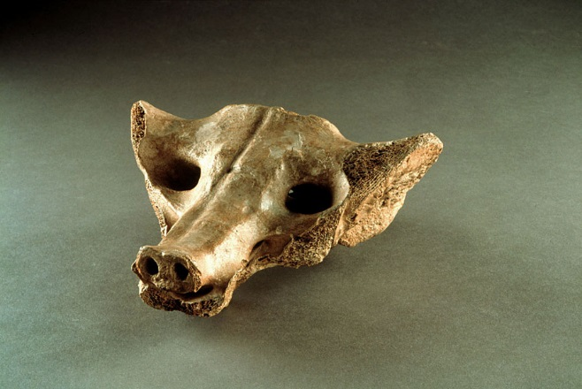

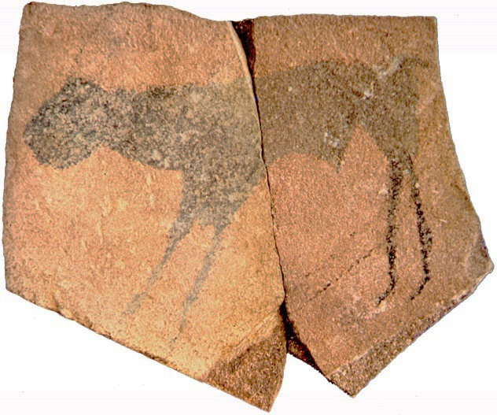

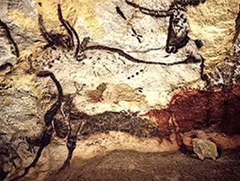

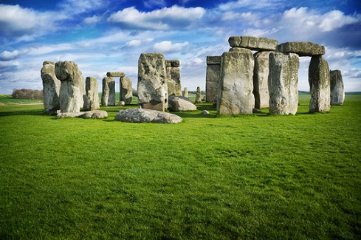

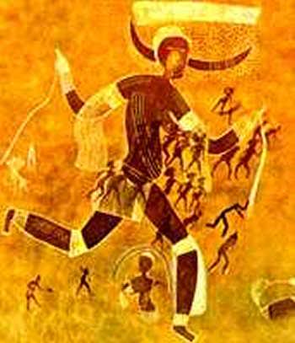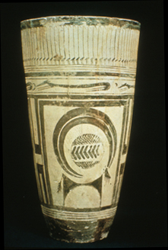

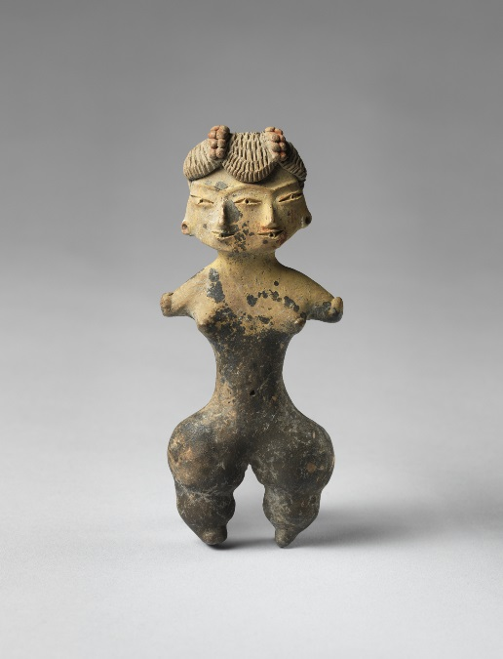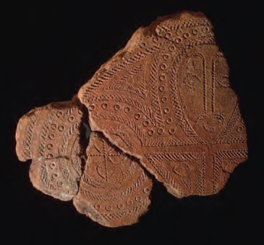

[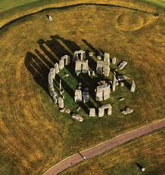](https://www.google.com/url?sa=i&rct=j&q=&esrc=s&source=images&cd=&cad=rja&uact=8&ved=0ahUKEwiG69_q0c_MAhVFdD4KHS5SBLMQjRwIBQ&url=https://secure-media.collegeboard.org/digitalServices/pdf/ap/2013advances/content-area-1-global-prehistory.pdf&psig=AFQjCNE4DRyesOXzQlOLXxfvC2xe-cWpng&ust=1462974213272162)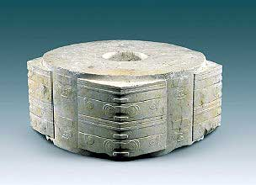Prehistoric